

PNNL Cost-Performance Tool (DOE-OE sponsored) for Estimation of Capital Costs for Redox Flow Batteries. Battelle IPID 30401.

Copyright © 2013, Battelle Memorial Institute  
All rights reserved.

**Instructions for using redox flow battery cost estimator PNNLBatGui.exe**

**September 10, 2013**

Alasdair Crawford 509-438-3916 [Alasdair.crawford@pnnl.gov](mailto:Alasdair.crawford@pnnl.gov)

Vilayanur Viswanathan 509-372-4745 vilayanur.viswanathan@pnnl.gov

Pacific Northwest National Laboratory

PNNL has developed an interactive tool to estimate the capital cost for PNNL all vanadium Gen 1, Gen2, and iron-vanadium chemistries. This tool has also been adapted for organic electrolyte redox flow batteries. The Gen 2 all vanadium system incorporates the PNNL-developed electrolyte with high concentration and wide operating temperature range. The tool allows determination of the most cost-effective chemistries and the optimum operating conditions for power or energy intensive applications, providing a strategy for a redox flow battery management system (BMS). This tool was developed with funding from The U. S. Department of Energy, Office of Electricity Delivery and Energy Reliability/Energy Storage Program, under the leadership of Dr. Imre Gyuk.

1. 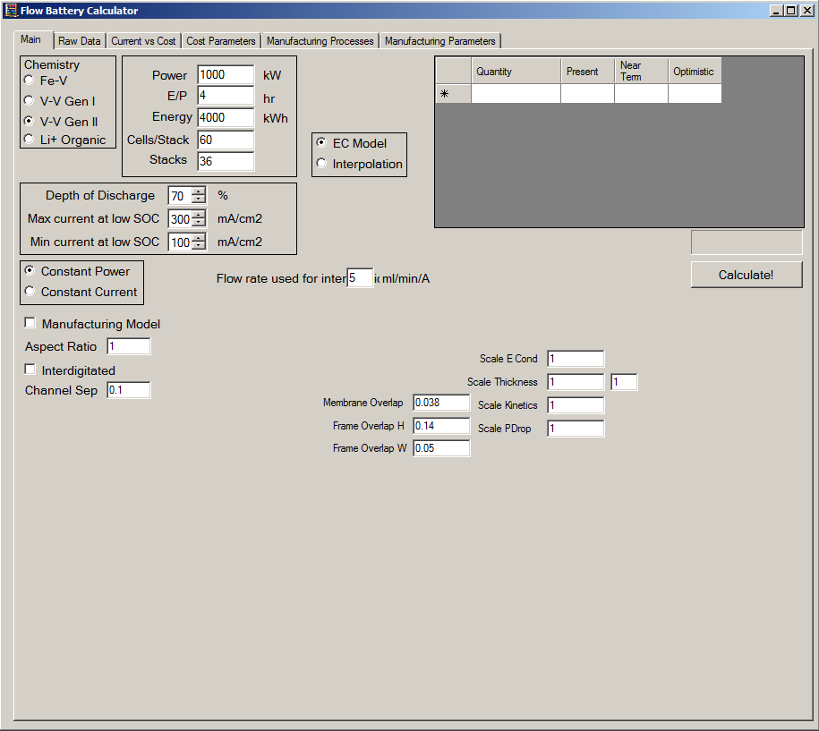In chemistry pane, select the cell chemistry to be used.
2. In the battery design pane, select the required power, the E/P ratio, the required energy, the cells per stack, and the number of stacks desired.
3. Select the depth of discharge (DOD) and the current ranges to investigate.
4. Select EC model or interpolation. Interpolation requires a *.csv file with voltage as a function of current and SOC. For an example of how to format your data, see example.csv in the zip file. Note that an arbitrary amount of data points can be entered. EC model uses built in electrochemical model to calculate voltage. If interpolating a flow rate per amp must be entered.
5. Select constant power or constant current. The former reduces current at higher SOCs to provide a constant power for increased efficiency. The latter uses the current at low SOC for all SOCs.
6. If desired the manufacturing model and/or the interdigitated model can be turned on.
7. Select calculate.

Please note that in some instances, the program will give an error message if, for the range of current density values selected, the current densities are too low, too high or both for the DOD selected. For example, let us assumesome of the current densities investigated are too low, while none are too high. The error message will state that the current density is too low. Increase the current density till you get stable results. Same applies if current density is too high. Decrease the current density till you get stable results.

In short, for a selecteted DOD, the stable current density range selected can be found by trial and error for your chemistry.

1. The results of the calculation are displayed in this pane. The costs and optimum current densities are returned.

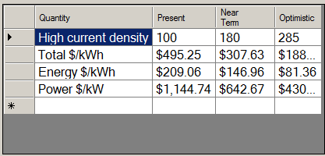

Advanced

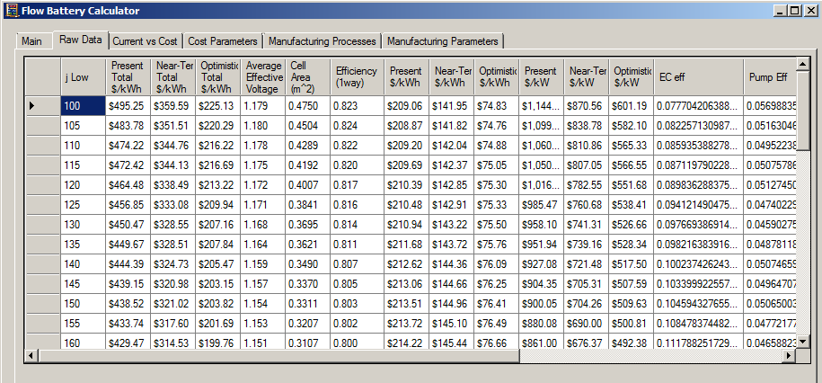

1. The raw data tab can be used to look at each current density’s results in depth. This can be used to look at cell area, efficiency, efficiency loss each from pumping, shunt, and electrochemistry, and flow rates used.

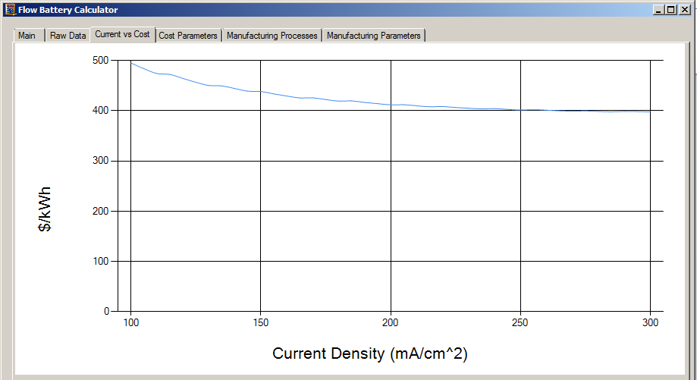

1. The current vs cost tab can be used to graphically look at how the total cost varied with current density.

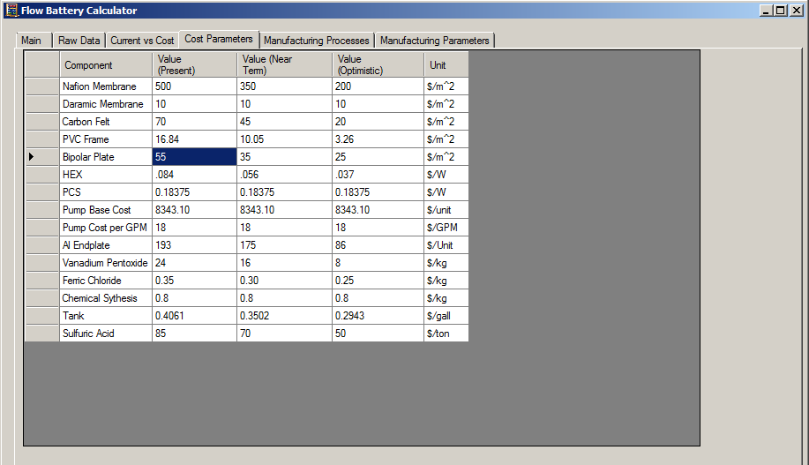

1. The cost parameters tab can be used to customize the cost of each component.